Linux Containers Lab Guide with Command Explanations and Screenshot Placeholders

Step 1 - Pull Ubuntu Image
Command: docker pull ubuntu:24.04
Explanation: Downloads the Ubuntu Linux image from Docker Hub to your local machine. Images are templates used to create containers.
Expected Output: 24.04: Pulling from library/ubuntu
532a4cf7e47b: Download complete
Digest: sha256:786a8b558f7be160c6c8c4a54f9a57274f3b4fb1491cf65146521ae77ff1dc54
Status: Downloaded newer image for ubuntu:24.04
docker.io/library/ubuntu:24.04
Screenshot Placeholder (Paste Screenshot Below):
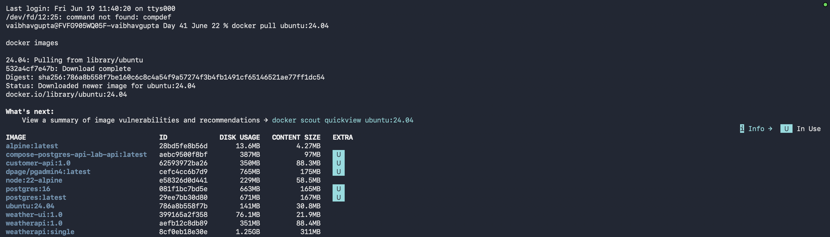
______________________________________________

Step 2 - Verify Image
Command: docker images
Explanation: Displays all images stored locally on your computer.
Expected Output: vaibhavgupta@FVFG905WQ05F-vaibhavgupta Day 41 June 22 % docker images
i Info → U In Use
IMAGE ID DISK USAGE CONTENT SIZE EXTRA
alpine:latest 28bd5fe8b56d 13.6MB 4.27MB U
compose-postgres-api-lab-api:latest aebc9500f8bf 387MB 97MB U
customer-api:1.0 62593972ba26 350MB 88.3MB U
dpage/pgadmin4:latest cefc4cc6b7d9 765MB 175MB U
node:22-alpine e58326d0d441 229MB 58.5MB
postgres:16 081f1bc7bd5e 663MB 165MB U
postgres:latest 29ee7bb30d80 671MB 167MB U
ubuntu:24.04 786a8b558f7b 141MB 30.8MB U
weather-ui:1.0 399165a2f358 76.1MB 21.9MB
weatherapi:1.0 aefb12c8db89 351MB 88.4MB
weatherapi:single 8cf0eb18e30e 1.25GB 311MB
Screenshot Placeholder (Paste Screenshot Below):
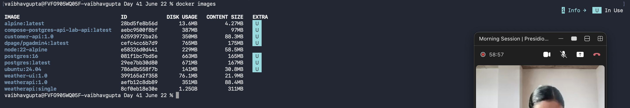

Step 3 - Start Ubuntu Container
Command: docker run -it ubuntu:24.04 bash
Explanation: Creates and starts a container from the Ubuntu image and opens an interactive Bash shell.
Expected Output: vaibhavgupta@FVFG905WQ05F-vaibhavgupta Day 41 June 22 % docker run -it ubuntu:24.04 bash
root@5f7ddcef7de8:/#
Screenshot Placeholder (Paste Screenshot Below):

Step 4 - Check Current Directory
Command: pwd
Explanation: Prints the current working directory.
Expected Output: root@5f7ddcef7de8:/# pwd
/
Screenshot Placeholder (Paste Screenshot Below):

Step 5 - List Files
Command: ls -la
Explanation: Displays all files and folders including hidden files.
Expected Output: root@5f7ddcef7de8:/# ls -la
total 56
drwxr-xr-x 1 root root 4096 Jun 22 04:56 .
drwxr-xr-x 1 root root 4096 Jun 22 04:56 ..
-rwxr-xr-x 1 root root 0 Jun 22 04:56 .dockerenv
lrwxrwxrwx 1 root root 7 Apr 22 2024 bin -> usr/bin
drwxr-xr-x 2 root root 4096 Apr 22 2024 boot
drwxr-xr-x 5 root root 360 Jun 22 04:56 dev
drwxr-xr-x 1 root root 4096 Jun 22 04:56 etc
drwxr-xr-x 3 root root 4096 May 9 14:23 home
lrwxrwxrwx 1 root root 7 Apr 22 2024 lib -> usr/lib
drwxr-xr-x 2 root root 4096 May 9 14:17 media
drwxr-xr-x 2 root root 4096 May 9 14:17 mnt
drwxr-xr-x 2 root root 4096 May 9 14:17 opt
dr-xr-xr-x 218 root root 0 Jun 22 04:56 proc
drwx------ 2 root root 4096 May 9 14:23 root
drwxr-xr-x 4 root root 4096 May 9 14:23 run
lrwxrwxrwx 1 root root 8 Apr 22 2024 sbin -> usr/sbin
drwxr-xr-x 2 root root 4096 May 9 14:17 srv
dr-xr-xr-x 11 root root 0 Jun 22 04:25 sys
drwxrwxrwt 2 root root 4096 May 9 14:23 tmp
drwxr-xr-x 11 root root 4096 May 9 14:17 usr
drwxr-xr-x 11 root root 4096 May 9 14:23 var

Screenshot Placeholder (Paste Screenshot Below):

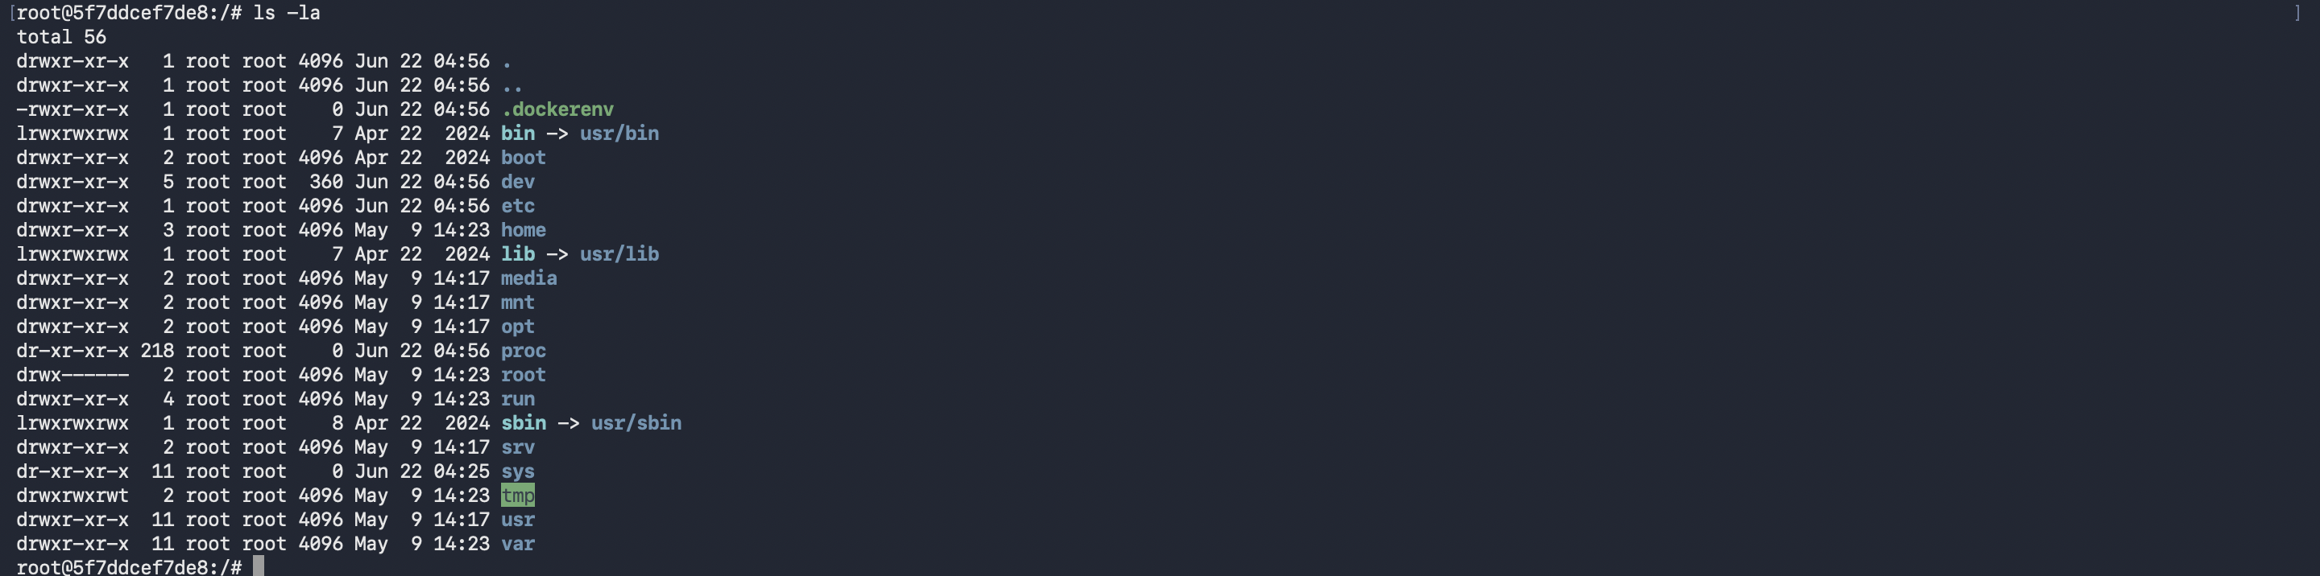

Step 6 - View Linux Version
Command: cat /etc/os-release
Explanation: Displays operating system information.
Expected Output: PRETTY_NAME="Ubuntu 24.04.4 LTS"
NAME="Ubuntu"
VERSION_ID="24.04"
VERSION="24.04.4 LTS (Noble Numbat)"
VERSION_CODENAME=noble
ID=ubuntu
ID_LIKE=debian
HOME_URL="https://www.ubuntu.com/"
SUPPORT_URL="https://help.ubuntu.com/"
BUG_REPORT_URL="https://bugs.launchpad.net/ubuntu/"
PRIVACY_POLICY_URL="https://www.ubuntu.com/legal/terms-and-policies/privacy-policy"
UBUNTU_CODENAME=noble
LOGO=ubuntu-logo
Screenshot Placeholder (Paste Screenshot Below):

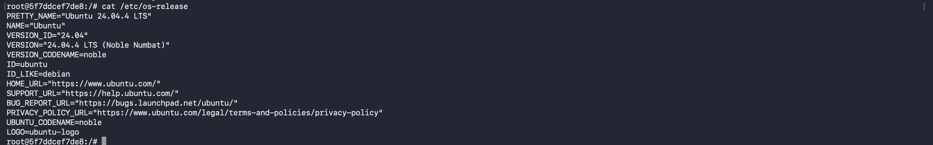 Step 7 - Check Current User
Command: whoami
Explanation: Displays the currently logged-in user.
Expected Output root@5f7ddcef7de8:/# whoami
root
Screenshot Placeholder (Paste Screenshot Below):

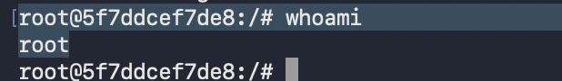

Step 8 - Create File
Command: touch notes.txt
Explanation: Creates an empty file named notes.txt.
Expected Output:
Screenshot Placeholder (Paste Screenshot Below):
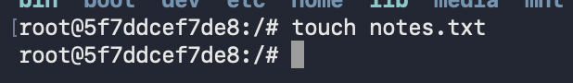

Step 9 - Write Data
Command: echo "Hello Docker" > notes.txt
Explanation: Writes text into a file.
Expected Output: ______________________________________________
Screenshot Placeholder (Paste Screenshot Below):

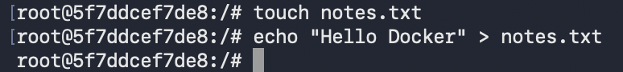 Step 10 - Create Folder
Command: mkdir training
Explanation: Creates a new directory.
Expected Output: ______________________________________________
Screenshot Placeholder (Paste Screenshot Below):
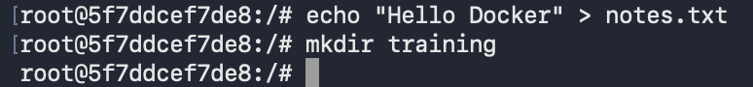
______________________________________________

Step 11 - View Processes
Command: ps -ef
Explanation: Displays running processes inside the container.
Expected Output: UID PID PPID C STIME TTY TIME CMD
root 1 0 0 04:56 pts/0 00:00:00 bash
root 15 1 0 05:01 pts/0 00:00:00 ps -ef
Screenshot Placeholder (Paste Screenshot Below):
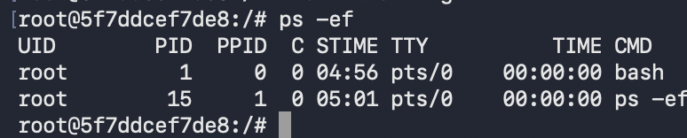

Step 12 - Install Software
Commands: apt update && apt install curl -y
Explanation: Updates package repositories and installs curl.
Expected Output: ______________________________________________
Screenshot Placeholder (Paste Screenshot Below):
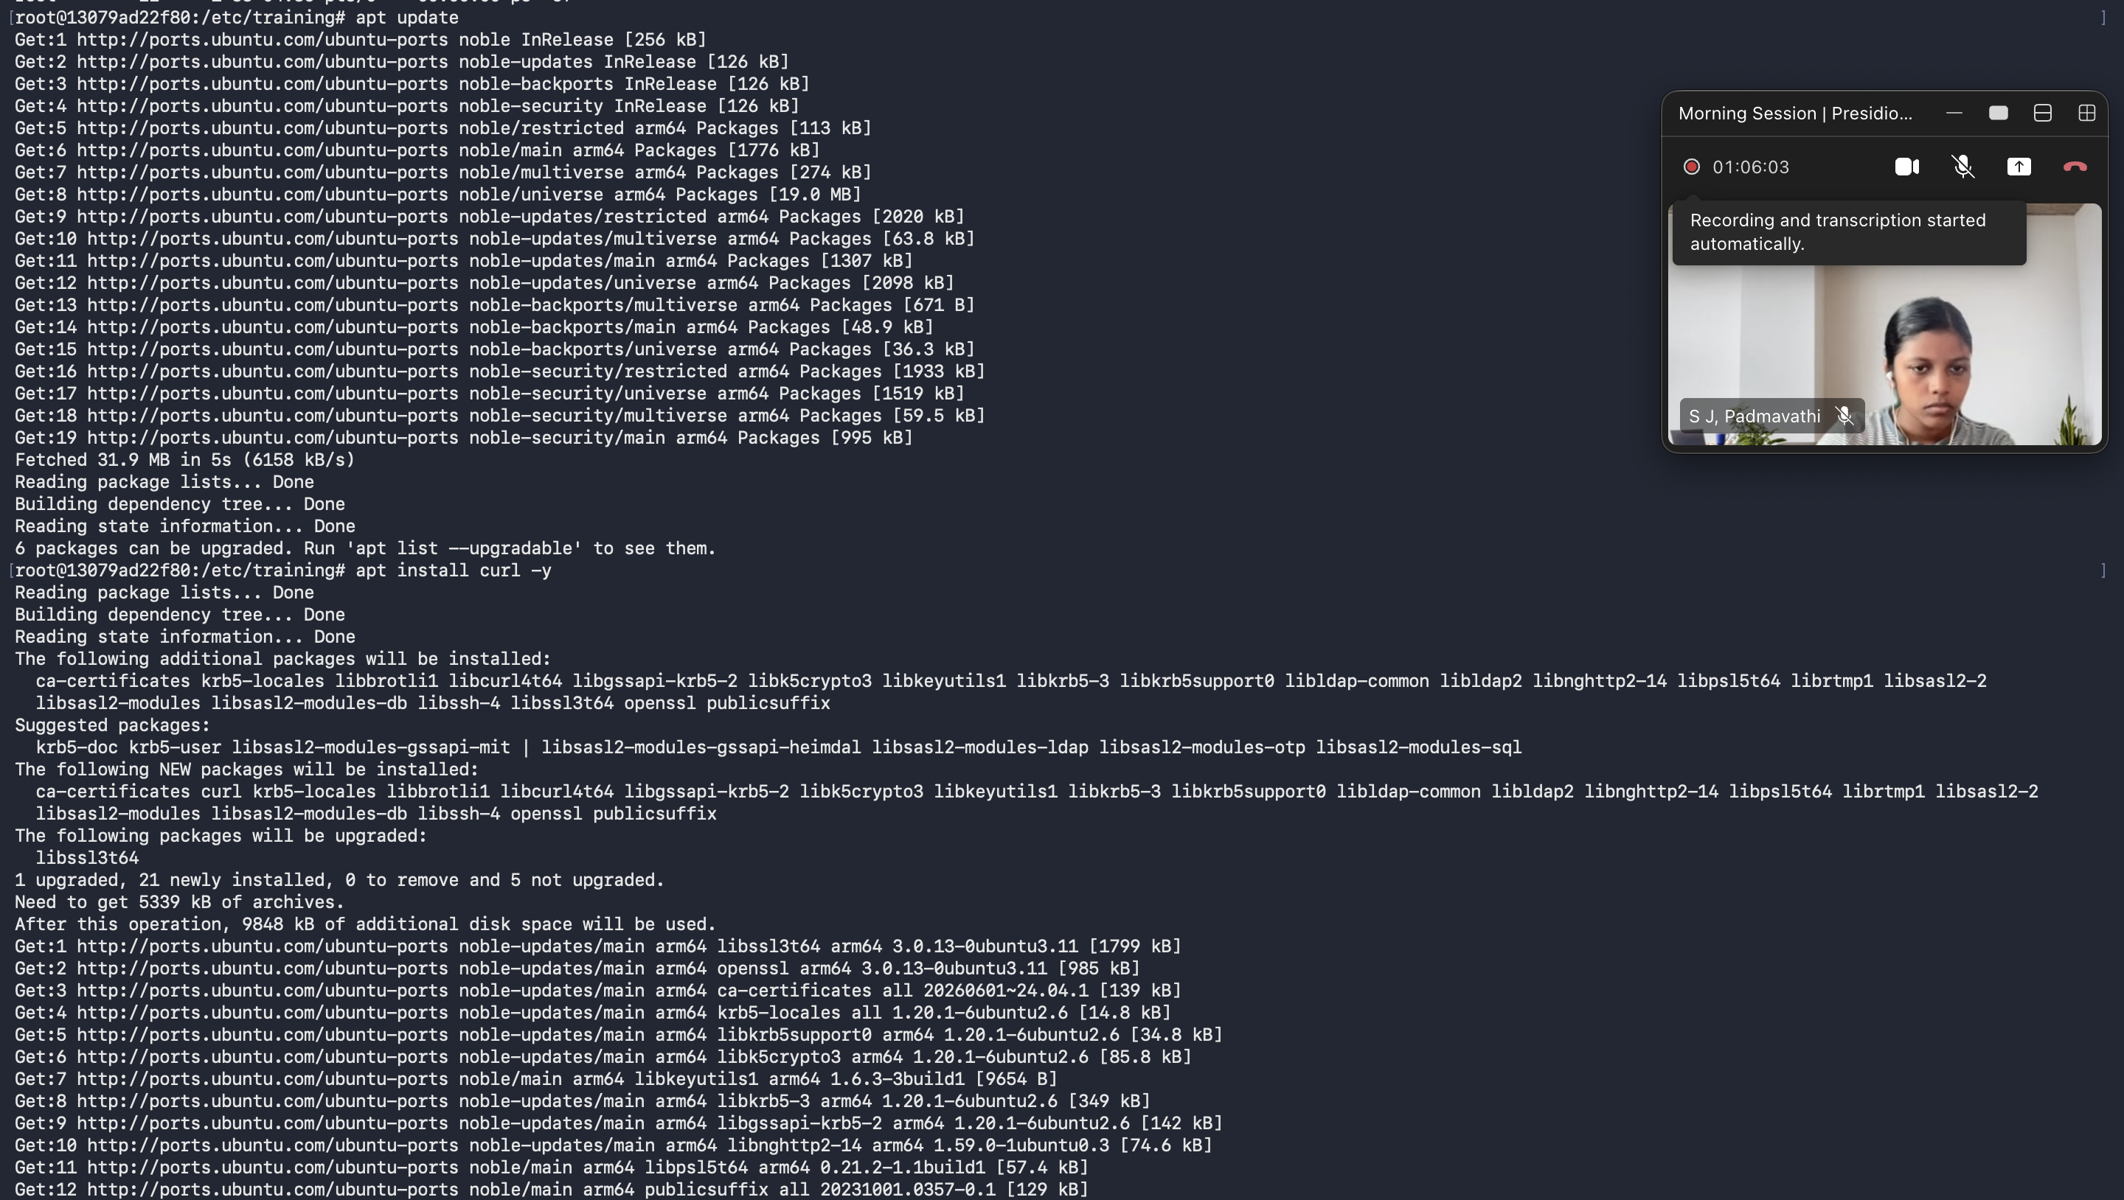

Step 13 - Networking
Commands: hostname, hostname -I
Explanation: Displays hostname and IP address.
Expected Output: ______________________________________________
Screenshot Placeholder (Paste Screenshot Below):
______________________________________________

Step 14 - Create User
Command: useradd student
Explanation: Creates a new Linux user.
Expected Output: ______________________________________________
Screenshot Placeholder (Paste Screenshot Below):

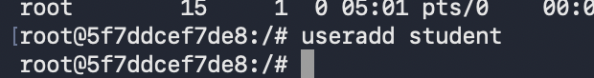

Step 15 - Permissions
Command: chmod 777 secret.txt
Explanation: Changes file permissions to full access.
Expected Output: ______________________________________________
Screenshot Placeholder (Paste Screenshot Below):

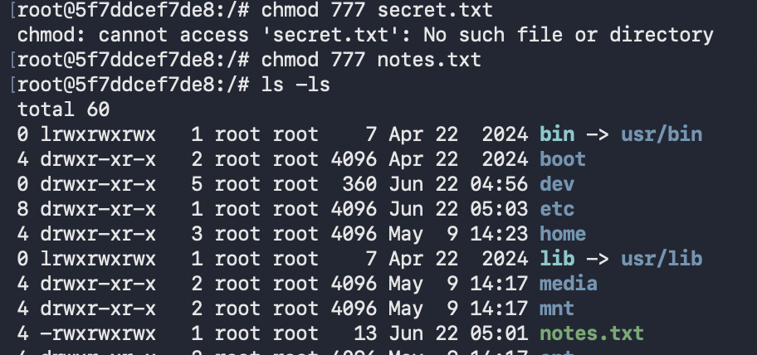 Step 16 - Environment Variables
Command: export COMPANY=Training
Explanation: Creates an environment variable.
Expected Output: ______________________________________________
Screenshot Placeholder (Paste Screenshot Below):

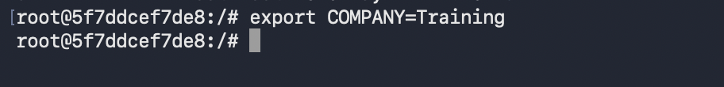

Step 17 - Exit Container
Command: exit
Explanation: Leaves the container shell.
Expected Output: exit
Screenshot Placeholder (Paste Screenshot Below):
